Full Name: Sumilhig, Paul Brian M Date: 31/10/2025
Subject/Section: SSYADD-SS231
Group Name: ALT_RUN
Project Name: E-ksena

Link to Openproject Board: | Link |
Openproject Board screenshot
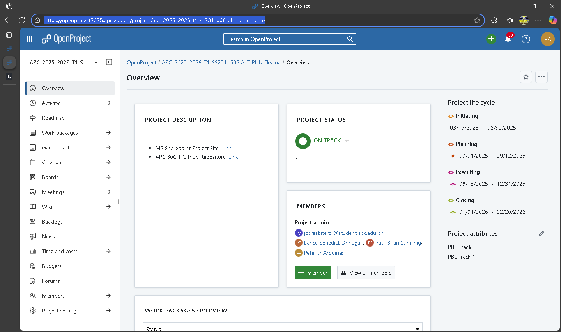
Screenshot of individual contribution of Entities to the ERD
Making the DFD

Figure 1. Dataflow Diagram Level 0
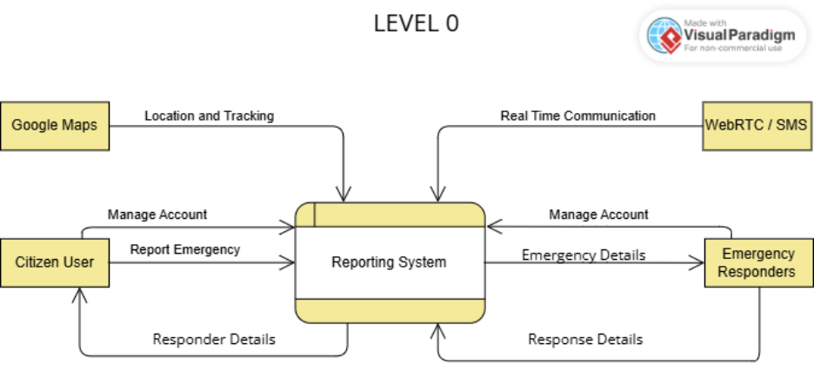

Figure 2. Dataflow Diagram Level 2
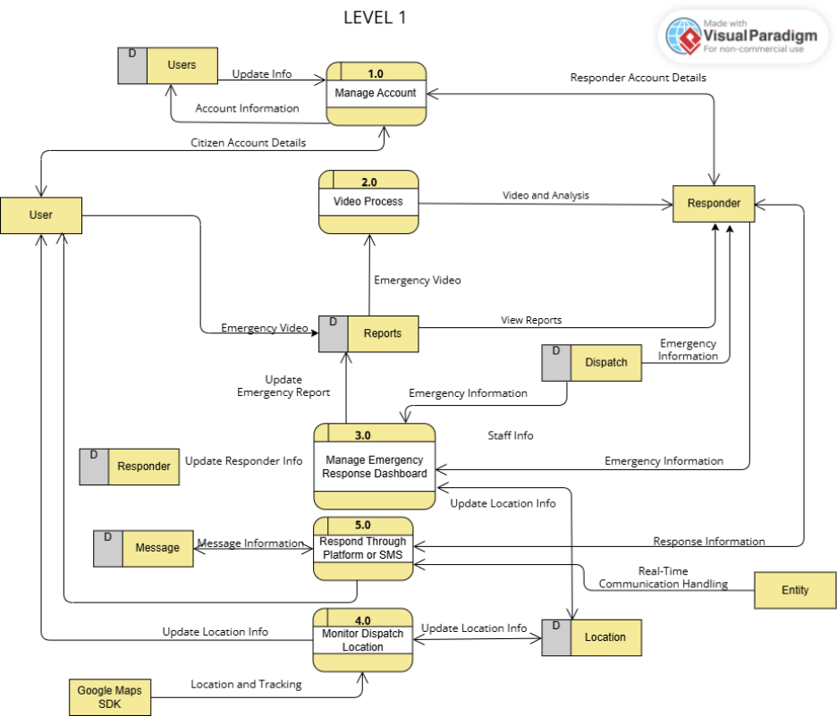

Figure 3. Dataflow Diagram Level 2.1: Login Process

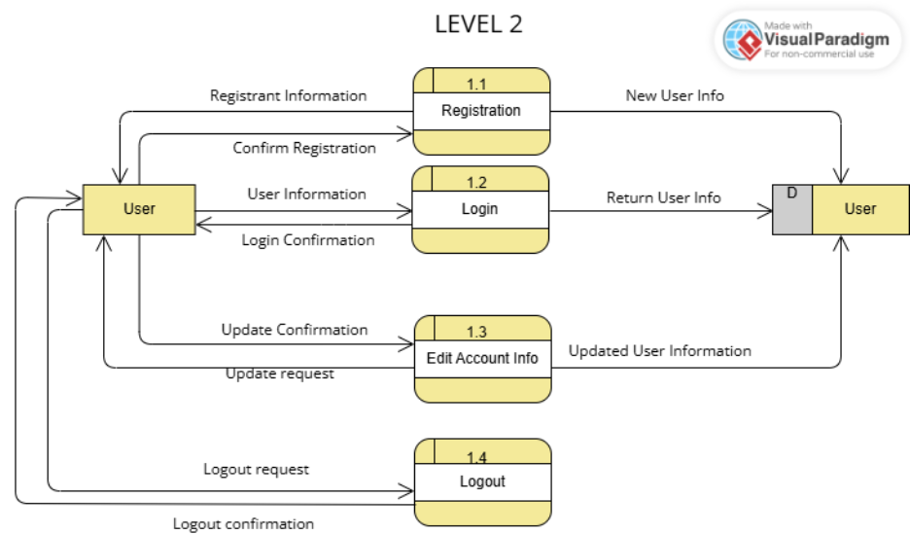
Figure 4. Dataflow Diagram Level 2.2: AI Analysis
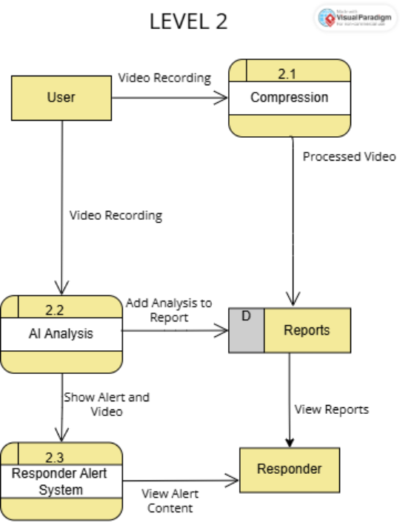
Figure 5. Dataflow Diagram Level 2.3: Dashboard

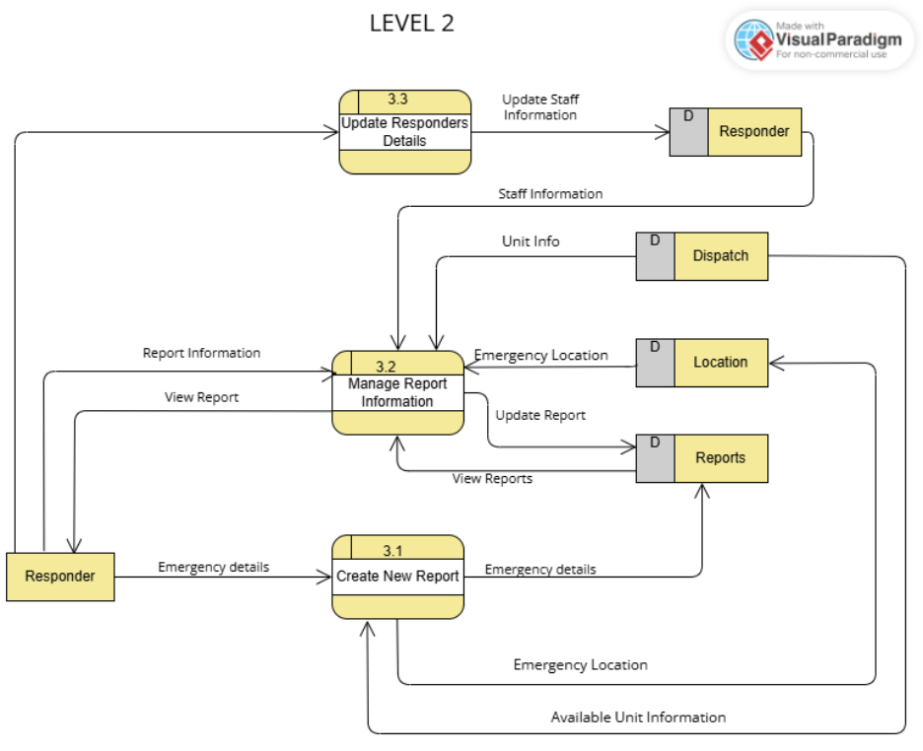

Figure 6. Dataflow Diagram Level 2.4: Traffic and Location Tracking

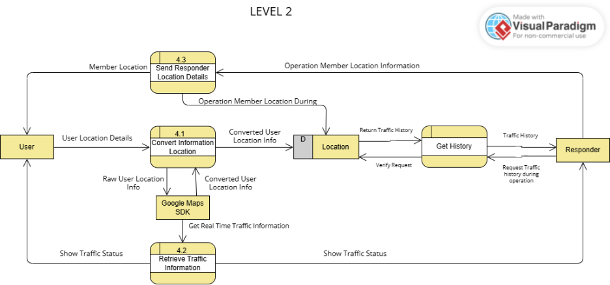
Figure 7. Dataflow Diagram Level 2.5: Messaging
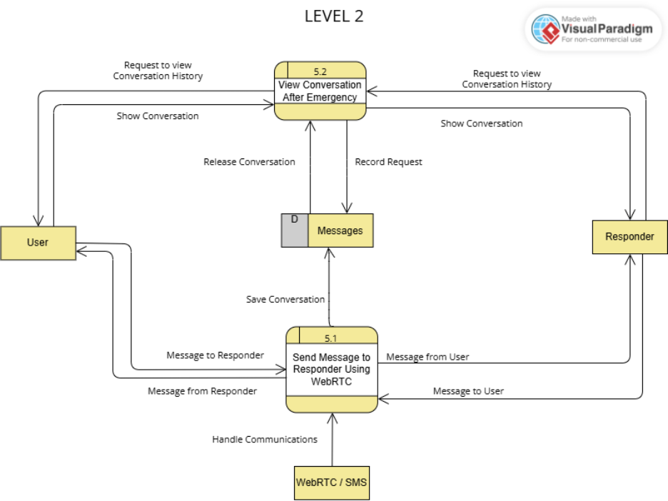

Link to the Data Flow Diagram |Link|

Hours estimated: 4 hours
Hours spent: 4 hours 22 minutes

